EX.NO: | Simulation of Distance Vector Routing Algorithm
DATE: | Simulation of Distance Vector Routing Algorithm

AIM:
To simulate and observe traffic route of a network using distance vector routing protocol.

ALGORITHM:
Step 1: Create a simulator object
Step 2: Set routing protocol to Distance vector routing
Step 3: Trace packets on all links on to NAM trace and text trace file.
Step 4: Define finish procedure to close files, flash tracing and run NAM
Step 5: Create 5 nodes
Step 6: Specify the link characteristics between the nodes
Step 7: Describer their layout topology as a octagon
Step 8: Add UDP agent for node n0
Step 9: Create CBR traffic on the top of UDP and set traffic parameters
Step 10: Add NULL agent to node n3
Step 11: Connect source and sink
Step 12: Schedule as follows
    - Start traffic flow at 1.0
    - Down the link n1 – n2 at 15.0
    - Up the link n1 – n2 at 25.0
    - Call finish procedure at 35.0
Step 13: Start the scheduler
Step 14: Observe the traffic route when the link is up and down
Step 15: View the simulated events and trace file analyze it
Step 16: Stop.

PROGRAM:
#Create a simulator object
set ns [new Simulator]

#Use distance vector routing
$ns rtproto DV

#Open the nam trace file
set nf [open out.nam w]
$ns namtrace-all $nf

# Open tracefile
set nt [open trace.tr w]
$ns trace-all $nt

#Define 'finish' procedure
proc finish {} {
global ns nf
$ns flush-trace
#Close the trace file
close $nf
#Execute nam on the trace file
exec nam -a out.nam &
exit 0
}

# Create 8 nodes
set n1 [$ns node]
set n2 [$ns node]
set n3 [$ns node]
set n4 [$ns node]
set n5 [$ns node]
set n6 [$ns node]
set n7 [$ns node]
set n8 [$ns node]

# Specify link characterestics
$ns duplex-link $n1 $n2 1Mb 10ms DropTail
$ns duplex-link $n2 $n3 1Mb 10ms DropTail
$ns duplex-link $n3 $n4 1Mb 10ms DropTail
$ns duplex-link $n4 $n5 1Mb 10ms DropTail
$ns duplex-link $n5 $n6 1Mb 10ms DropTail
$ns duplex-link $n6 $n7 1Mb 10ms DropTail
$ns duplex-link $n7 $n8 1Mb 10ms DropTail
$ns duplex-link $n8 $n1 1Mb 10ms DropTail

# specify layout as a octagon
$ns duplex-link-op $n1 $n2 orient left-up
$ns duplex-link-op $n2 $n3 orient up
$ns duplex-link-op $n3 $n4 orient right-up
$ns duplex-link-op $n4 $n5 orient right
$ns duplex-link-op $n5 $n6 orient right-down
$ns duplex-link-op $n6 $n7 orient down
$ns duplex-link-op $n7 $n8 orient left-down
$ns duplex-link-op $n8 $n1 orient left

#Create a UDP agent and attach it to node n1
set udp0 [new Agent/UDP]
$ns attach-agent $n1 $udp0

#Create a CBR traffic source and attach it to udp0
set cbr0 [new Application/Traffic/CBR]
$cbr0 set packetSize_ 500
$cbr0 set interval_ 0.005
$cbr0 attach-agent $udp0

#Create a Null agent (a traffic sink) and attach it to node n4
set null0 [new Agent/Null]
$ns attach-agent $n4 $null0

#Connect the traffic source with the traffic sink
$ns connect $udp0 $null0

#Schedule events for the CBR agent and the network dynamics
$ns at 0.0 "$n1 label Source"
$ns at 0.0 "$n4 label Destination"
$ns at 0.5 "$cbr0 start"
$ns rtmodel-at 1.0 down $n3 $n4
$ns rtmodel-at 2.0 up $n3 $n4
$ns at 4.5 "$cbr0 stop"

#Call the finish procedure after 5 seconds of simulation time
$ns at 5.0 "finish"

#Run the simulation
$ns run

OUTPUT:

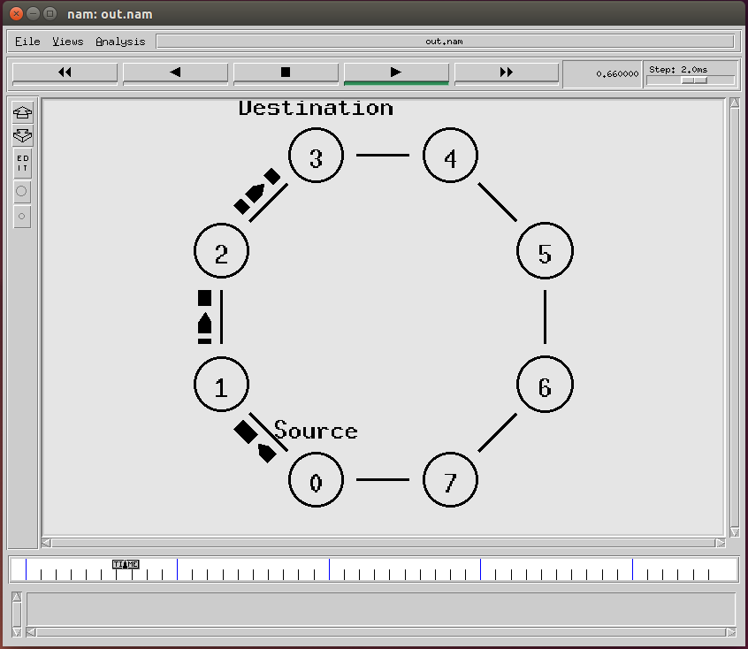
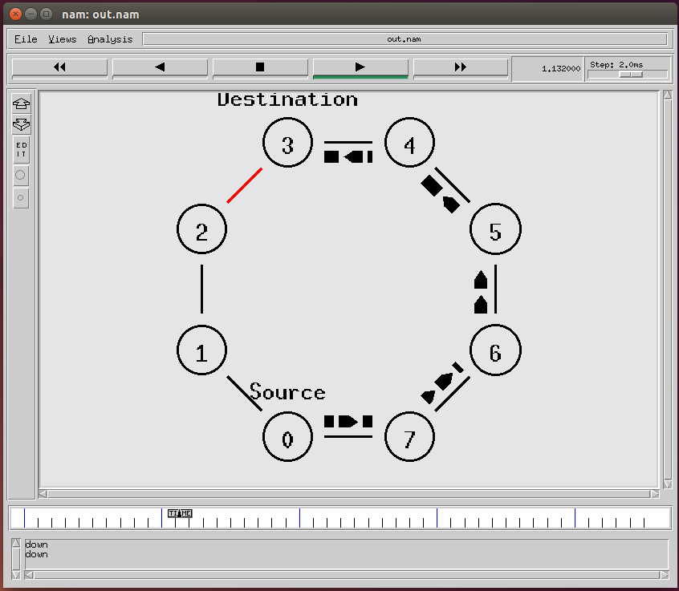

RESULT:
Thus the simulation of distance vector routing algorithm using ns2 has been executed successfully and output got verified.

